**Name: Shaheer Murtaza Shehri**

**CMS ID: 52638**

**Class: BS AI- 01**

**Subject: Object Oriented Programming**

**Assignment no 2**

**Instructor: Nazia Pervaiz**

* **Installing of vs code from the microsoft store:**

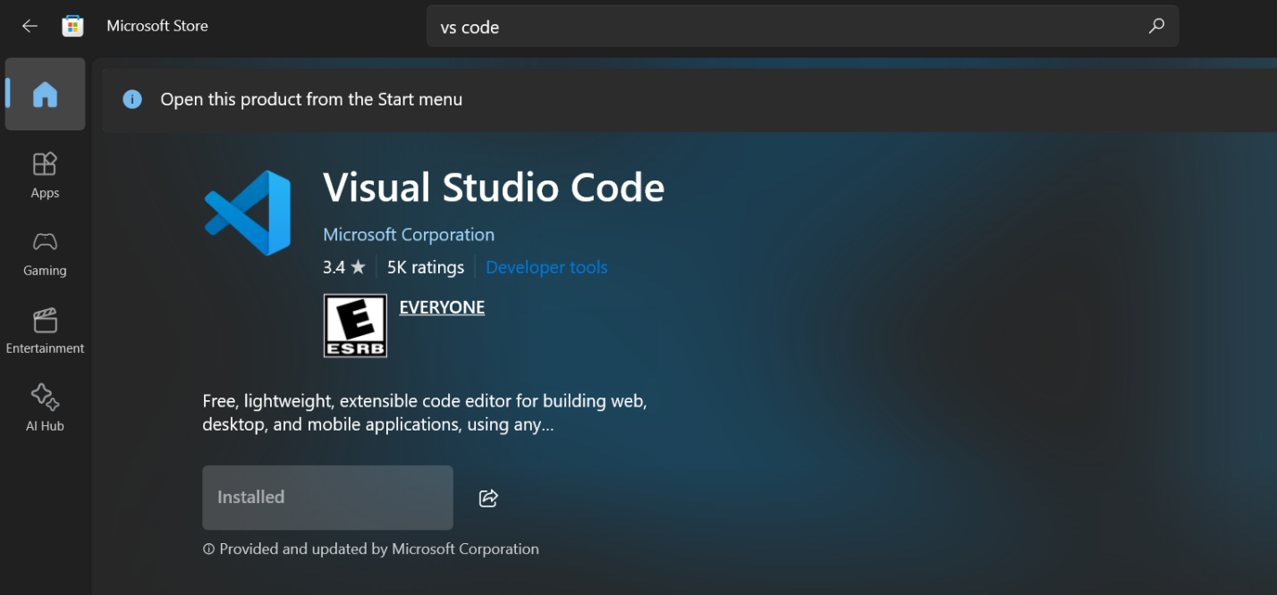

* **Downloadig of jdk:**

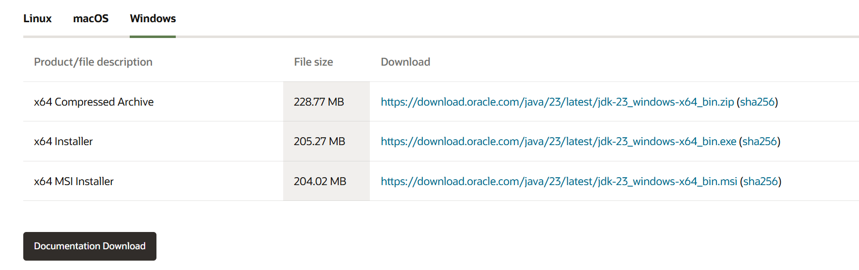

* **INSTALLING THE JAVA EXTENTIONS IN VS CODE:**

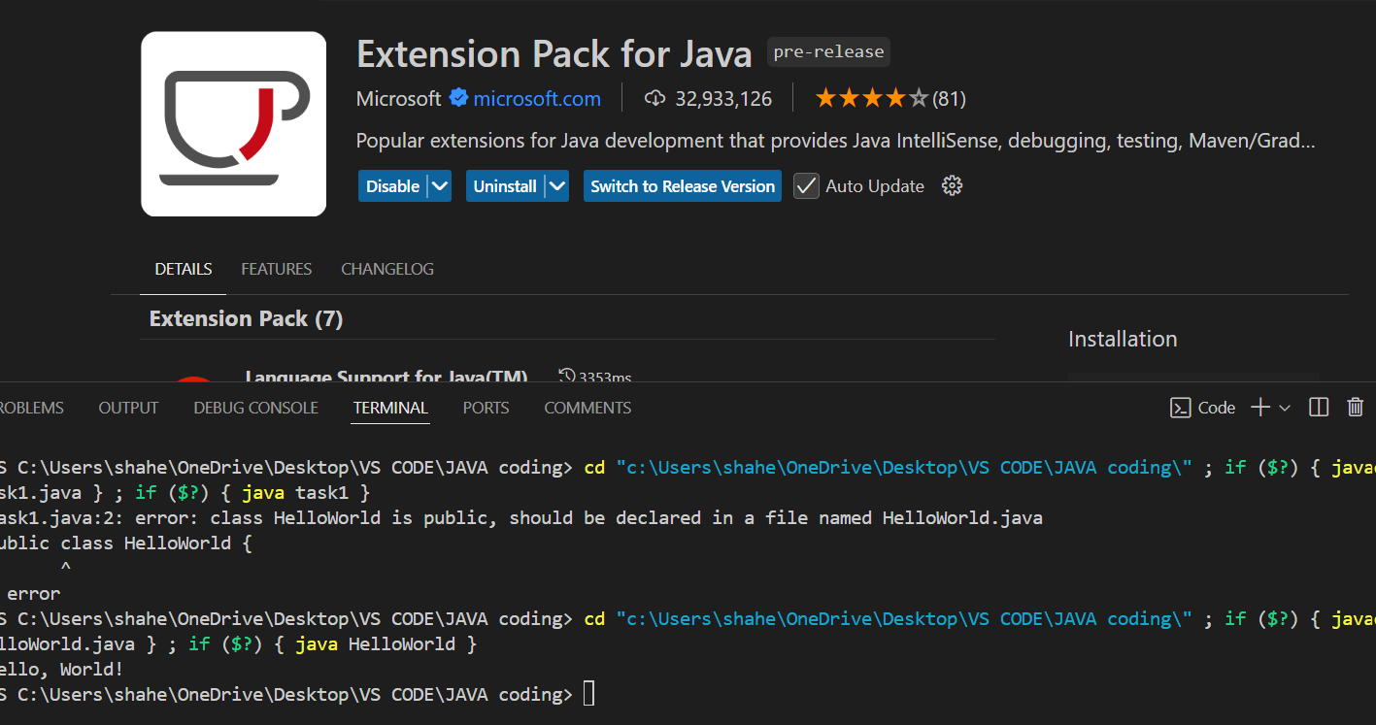

* **Making directories and files for the Java Classes:**

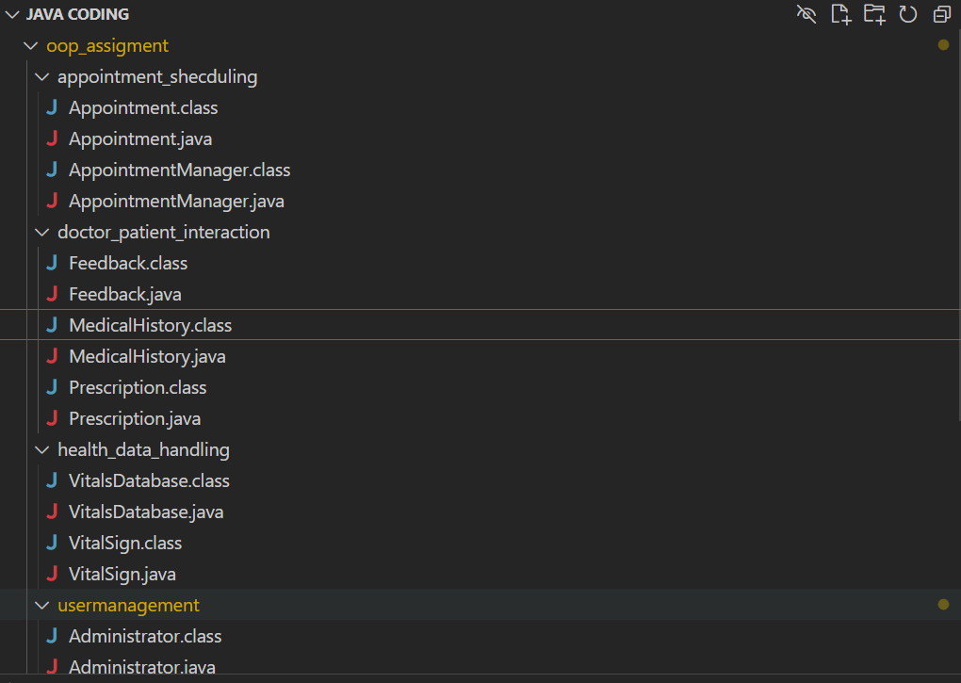

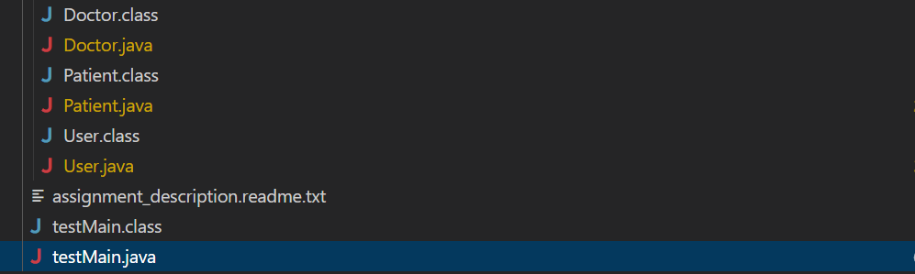

* **Code for the testMain:**

package oop_assigment;

import java.time.LocalDateTime;

import java.util.HashMap;

import oop_assigment.appointment_shecduling.Appointment;

import oop_assigment.appointment_shecduling.AppointmentManager;

import oop_assigment.doctor_patient_interaction.Feedback;

import oop_assigment.doctor_patient_interaction.MedicalHistory;

import oop_assigment.doctor_patient_interaction.Prescription;

import oop_assigment.health_data_handling.VitalSign;

import oop_assigment.health_data_handling.VitalsDatabase;

import oop_assigment.usermanagement.Administrator;

import oop_assigment.usermanagement.Doctor;

import oop_assigment.usermanagement.Patient;

public class testMain{

        public static void main(String[] args) {

                // Create Doctor instance

                Doctor doctor = new Doctor(

                        "U001", "D001", "Dr. Alice", "alice@hospital.com", "securePass",

                        "03123456789", "Karachi", 1980, 5, 20, "Cardiology",

                        "City Hospital", "Heart Dept", "15 years"

                );

                // Create Patient instance

                Patient patient = new Patient(

                        "U002", "P001", "Bob Khan", "bob@gmail.com", "bob1234","03456789012", "Lahore", 1995, 3, 10, "B+",

                        "70kg", "5.9ft", "Pollen", "03112223333", "ABC Insurance", 5000.0

                );

                // Create Administrator instance

                Administrator admin = new Administrator(

                        "U003", "A001", "Sarah Admin", "admin@hospital.com", "adminpass",

                        "03001112222", "Islamabad", 1985, 7, 25, "Admin Dept", "City Hospital"

                );

                // Create Vitals and add to database

                VitalSign vitals = new VitalSign(

                        "P001", "120/80", 72, 18, 98.6, 97.5, 90.0

                );

                VitalsDatabase vitalsDB = VitalsDatabase.getInstance();

                vitalsDB.addVitalSign("P001", vitals);

                // Create Prescription

                HashMap<String, String> meds = new HashMap<>();

                meds.put("Paracetamol", "2 times a day");

                meds.put("Antibiotic", "Once a day");

                Prescription prescription = new Prescription("PR001", meds, "5 days", "Take after meals");

                // Create Feedback and add Prescription

                Feedback feedback = new Feedback("FB001", "Good improvement seen.");

                feedback.addPrescription(prescription);

                // Create Medical History and add feedback

                MedicalHistory history = new MedicalHistory("P001");

                history.addFeedback(feedback);

                // Schedule Appointment

                Appointment appointment = new Appointment(

                        "AP001", "P001", "D001", LocalDateTime.of(2025, 4, 10, 14, 0),

                        "Routine Checkup", "Scheduled", 1500.0, 30

                );

                AppointmentManager apptManager = AppointmentManager.getInstance();

                apptManager.addAppointment( appointment);

                System.out.println("--- Demo Execution Completed Successfully ---");

        }

}

* **Creating instances for all classes and checking if it works without errors:**

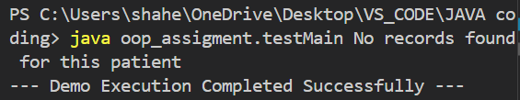

* **Code for the testMain with usage of functions of classes:**

package oop_assigment;

import java.time.LocalDateTime;

import java.util.HashMap;

import oop_assigment.appointment_shecduling.Appointment;

import oop_assigment.appointment_shecduling.AppointmentManager;

import oop_assigment.doctor_patient_interaction.Feedback;

import oop_assigment.doctor_patient_interaction.MedicalHistory;

import oop_assigment.doctor_patient_interaction.Prescription;

import oop_assigment.health_data_handling.VitalSign;

import oop_assigment.health_data_handling.VitalsDatabase;

import oop_assigment.usermanagement.Administrator;

import oop_assigment.usermanagement.Doctor;

import oop_assigment.usermanagement.Patient;

public class testMain{

        public static void main(String[] args) {

                // Doctor

                Doctor doctor = new Doctor(

                        "U001", "D001", "Dr. Alice", "alice@hospital.com", "securePass",

                        "03123456789", "Karachi", 1980, 5, 20, "Cardiology",

                        "City Hospital", "Heart Dept", "15 years"

                );

                // Patient

                Patient patient = new Patient(

                        "U002", "P001", "Bob Khan", "bob@gmail.com", "bob1234", "03456789012", "Lahore", 1995, 3, 10, "B+",

                        "70kg", "5.9ft", "Pollen", "03112223333", "ABC Insurance", 5000.0

                );

                // Administrator

                Administrator admin = new Administrator(

                        "U003", "A001", "Sarah Admin", "admin@hospital.com", "adminpass",

                        "03001112222", "Islamabad", 1985, 7, 25, "Admin Dept", "City Hospital"

                );

                // Vitals

                VitalSign vitals = new VitalSign(

                        "P001", "120/80", 72, 18, 98.6, 97.5, 90.0

                );

                VitalsDatabase vitalsDB = VitalsDatabase.getInstance();

                vitalsDB.addVitalSign("P001", vitals);

                // Prescription

                HashMap<String, String> meds = new HashMap<>();

                meds.put("Paracetamol", "2 times a day");

                meds.put("Antibiotic", "Once a day");

                Prescription prescription = new Prescription("PR001", meds, "5 days", "Take after meals");

                // Feedback

                Feedback feedback = new Feedback("FB001", "Good improvement seen.");

                feedback.addPrescription(prescription);

                // Medical History

                MedicalHistory history = new MedicalHistory("P001");

                history.addFeedback(feedback);

                // Appointment

                Appointment appointment = new Appointment(

                        "AP001", "P001", "D001", LocalDateTime.of(2025, 4, 10, 14, 0),

                        "Routine Checkup", "Scheduled", 1500.0, 30

                );

                appointment.setDoctorAvailability(true);  // Add this if required by logic

                AppointmentManager apptManager = AppointmentManager.getInstance();

                apptManager.addAppointment(appointment);

                // 💡 NEW: Schedule another appointment

                Appointment appointment2 = new Appointment(

                        "AP002", "P001", "D001", LocalDateTime.of(2025, 4, 15, 11, 30),

                        "Follow-up", "Scheduled", 1000.0, 20

                );

                appointment2.setDoctorAvailability(true);

                apptManager.addAppointment(appointment2);

                // Check all appointments

                System.out.println("\n--- All Appointments ---");

                apptManager.checkAllAppointments();

                // Check appointments for doctor

                System.out.println("\n--- Appointments for Doctor D001 ---");

                apptManager.checkDoctorAppointments("D001");

                // Check appointments for a patient

                System.out.println("\n--- Appointments for Patient P001 ---");

                apptManager.checkAppointments("P001");

                // View Medical History Feedbacks

                System.out.println("\n--- Feedback for Patient P001 ---");

                for (Feedback fb : history.getFeedbackList(patient.getPatient_id())) {

                        System.out.println("Feedback ID: " +patient.getPatient_id() );

                        System.out.println("Comment: ");fb.getFeedbackDetails();

                }

                // View Vital Signs

                System.out.println("\n--- Vital Signs for Patient P001 ---");

                vitalsDB.getPatientRecords("P001");

                // Remove an appointment

                System.out.println("\n--- Removing Appointment AP002 ---");

                apptManager.removeAppointment("P001", "AP002");

                // Confirm it's removed

                System.out.println("\n--- Appointments After Removal ---");

                apptManager.checkAppointments("P001");

                System.out.println("\n--- Demo Execution Completed Successfully ---");

        }

}

* **OUTPUT for the classes test and database creation:**

**Appointments:**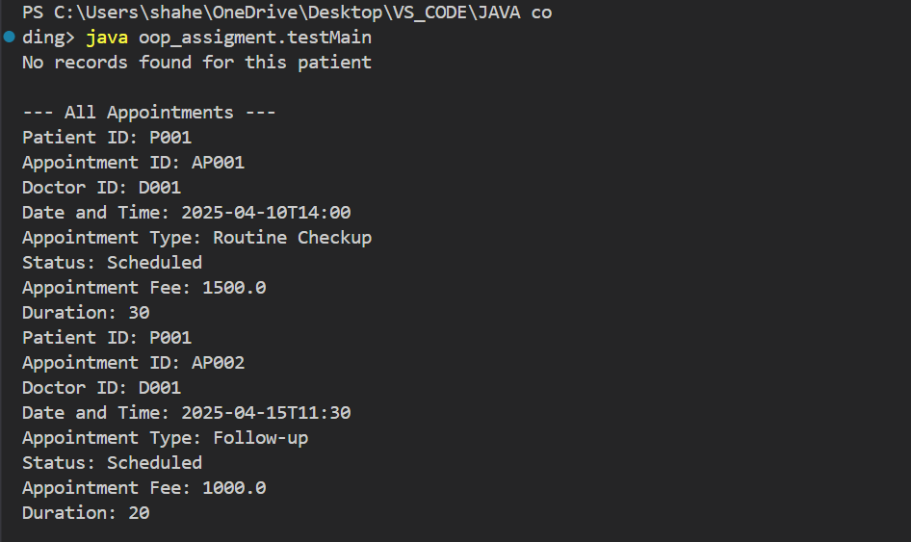

**Appointments associated with the doctor:**

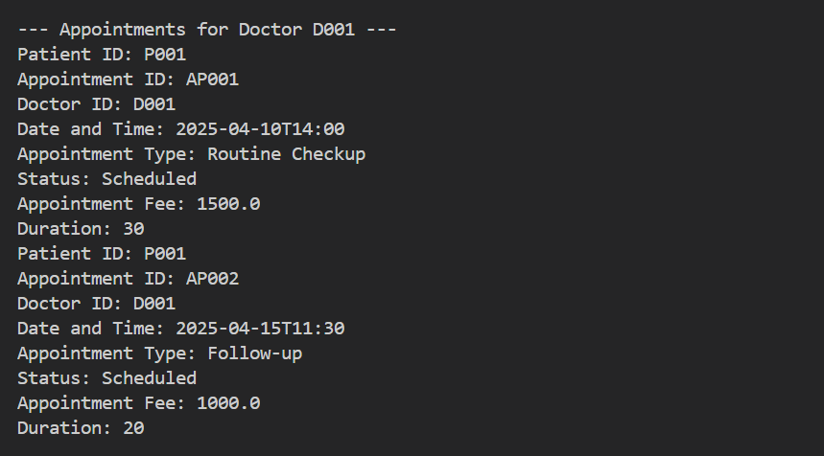

**Appointments associated with the patient:**

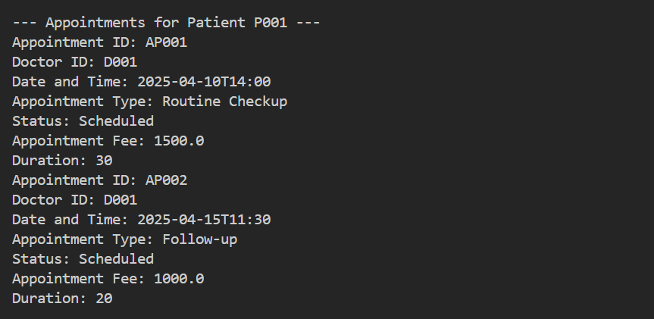

**Feedback associated with patient in feedback database:**

